put the whole project under  
c:\tmp\bin2csv

looks like below

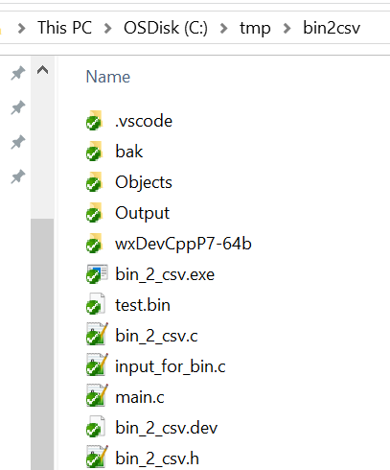

double click



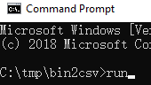 run

follow step and tips to input msg: to log date to bin file

or

convert bin to csv

if you want to build or modify source code

double click



to run DevCPP

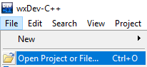



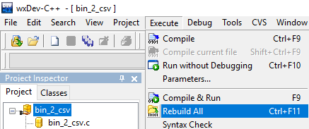

or

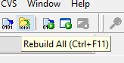

The code editor of DevC++ is very bad, if you have Visual Studio Code installed, then double click



will be much better….

